**Live share**

Visual Studio Live Share enables you to collaboratively edit and debug with others in real time, regardless what [programming languages](https://docs.microsoft.com/en-us/visualstudio/liveshare/reference/platform-support#visual-studio-code) you're using or app types you're building. It allows you to instantly (and [securely](https://docs.microsoft.com/en-us/visualstudio/liveshare/reference/security)) share your current project, and then as needed, share [debugging sessions](https://docs.microsoft.com/en-us/visualstudio/liveshare/use/vscode#co-debugging), [terminal instances](https://docs.microsoft.com/en-us/visualstudio/liveshare/use/vscode#share-a-terminal), [localhost web apps](https://docs.microsoft.com/en-us/visualstudio/liveshare/use/vscode#share-a-server), [voice calls](https://aka.ms/vsls-audio), and more! Developers that join your sessions receive all of their editor context from your environment (e.g. language services, debugging), which ensures they can start productively collaborating immediately, without needing to clone any repos or install any SDKs.

Additionally, unlike traditional pair programming, Visual Studio Live Share allows developers to work together, while retaining their personal editor preferences (e.g. theme, keybindings), as well as having their own cursor. This allows you to seamlessly transition between [following one another](https://docs.microsoft.com/en-us/visualstudio/liveshare/use/vscode#following), and being able to explore ideas/tasks on your own. In practice, this ability to work together and independently provides a collaboration experience that is potentially more natural for many [common use cases](https://docs.microsoft.com/en-us/visualstudio/liveshare/reference/use-cases).

**Flow Chart**

**Install Live Share Extension on VS Code**

[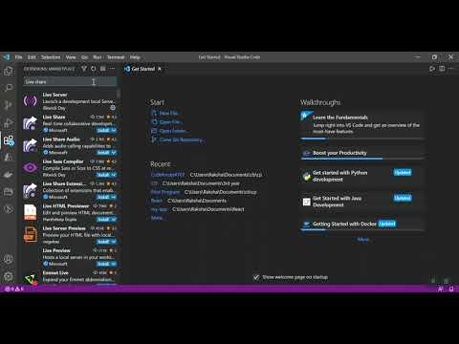](https://www.youtube.com/embed/HCI3vQeuu_Q?feature=oembed)

**Share or Join a session via Live Share Extension on VS Code**

[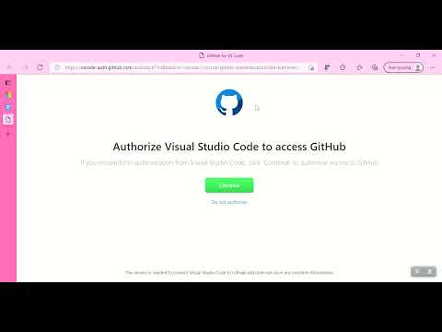](https://www.youtube.com/embed/YLnbtcDvDdI?feature=oembed)

Once done,

User1

User2 (After Clicking on the shared link)

After extablishing the connection,

User1-

User2

Note: if windows defender shows warning and asks to allow access – please grant the access to allow the features.